Blackboard Learn for

REST and LTI Developers EC2: Migration/Transfer
- Version: v.3400.9.0 | - Last updated: Oct 1, 2018
Currently, there is no formal migration/transfer tool to port Blackboard Learn data between EC2 instances. However, there are several existing administrative tools that can be leveraged to capture the bulk of T&L (teaching/learning data) like courses, users, institutional roles, and enrollments, etc. from an existing (source) EC2 and reinstate/recreate the data onto a (new) EC2.
Before following the steps below, ensure that you can access your source EC2 and destination EC2 via Front-end UI (web browser), SSH, SFTP & Postgres.

Upgrading Instance Type (if needed):
The course Import-Export script (batch_ImportExport.sh) requires a dedicated minimum JVM Heap size of 4GB in addition to that of Blackboard Learn. This requires an Instance Type of at least t2.large (larger than the default t2.medium instance type). If the Instance Type of the Source EC2 and/or the Destination EC2 is smaller than t2.large, perform the steps below to upgrade the Instance Type as necessary. Be sure to upgrade the Instance Type of the Source EC2 and the Destination EC2.
 | Locate the Instance: Go to the EC2 Dashboard: AWS Services Compute EC2. Under “Resources”, click on your Running Instances. | 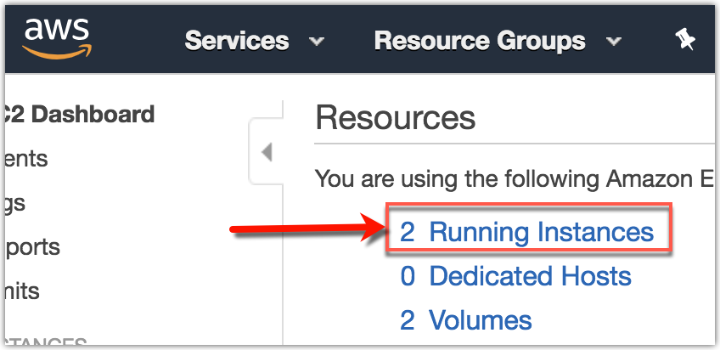
 | Stop the Instance: Right-click on the desired Instance, and select Instance State Stop | 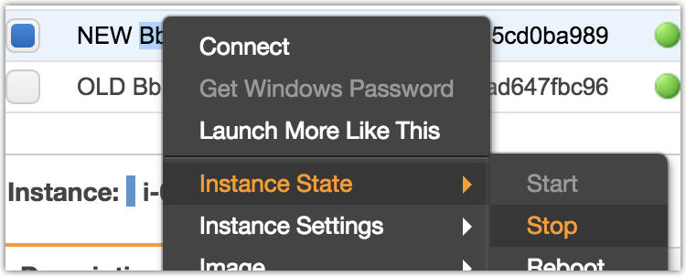
 | Change Instance Type: Right-click on the desired Instance, and select Instance Settings Change Instance Type. Select a new Instance Type of t2.large (or larger), and click Apply | 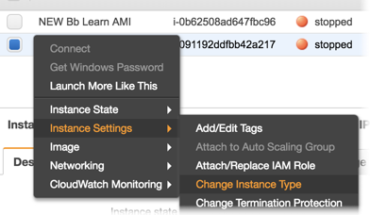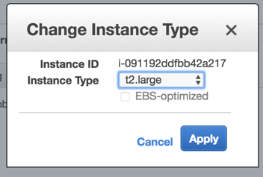
 | Start the Instance: After applying the Instance Type change, right-click on the desired Instance, and select Instance State Start | 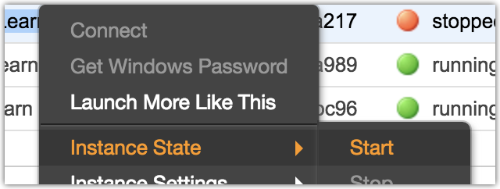

Customize the JVM heap size for the batch_ImportExport tool:
The course Import-Export script (batch_ImportExport.sh) requires a dedicated minimum JVM Heap size of 4GB in addition to that of Blackboard Learn. Be sure to add the custom JVM option to the batch_ImportExport.sh script on the Source EC2 and the Destination EC2.
 | SSH into your EC2 and open the batch_ImportExport.sh file for editing:  sudo nano /usr/local/blackboard/apps/content-exchange/bin/batch_ImportExport.sh | 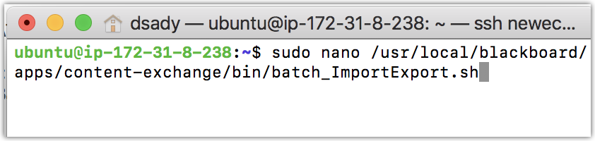
 | Scroll down to the OPTS section, and add an additional parameter to set the customized JVM heap size to a minimum of 4GB:  OPTS="$OPTS -Xmx4g" | 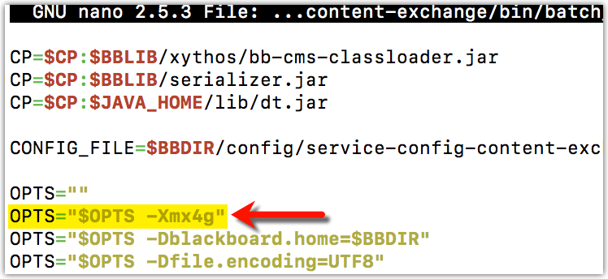
 | Exit (^X), save (Y), and update (Enter) the file (back to /usr/local/blackboard/apps/content-exchange/bin/batch_ImportExport.sh) | 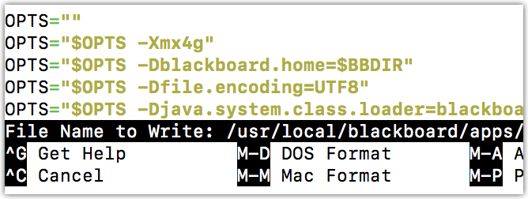

Capturing T&L Data from Source EC2:
 | Capture system users: On the Source EC2, run SQL to pull a list of real users in Snapshot Flat File format:  USERS_Query_to_Snapshot_Flat_File.sql  Save the results of the query output as a tab-delimited text file. It should resemble this example:  USERS_Snapshot_Flat_File_example.txt | 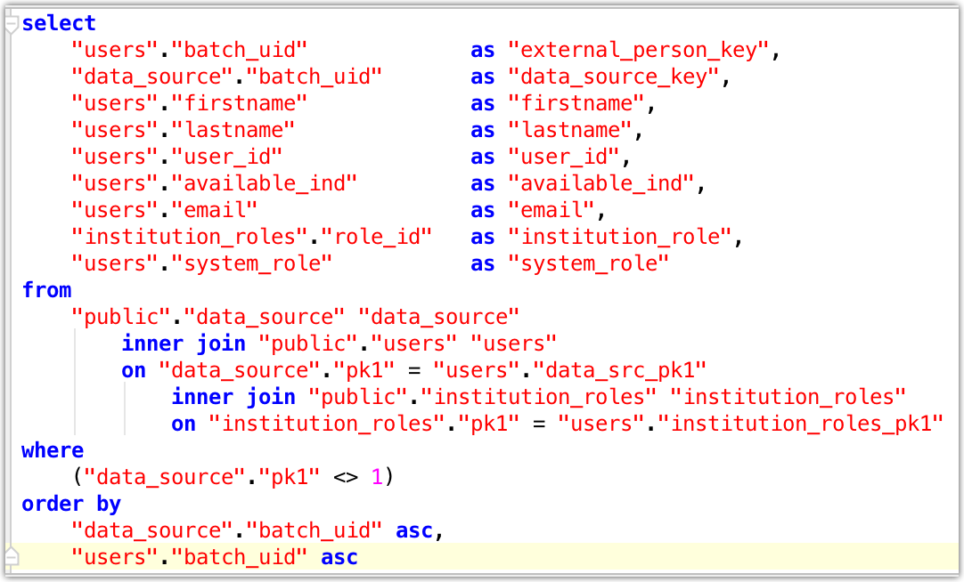  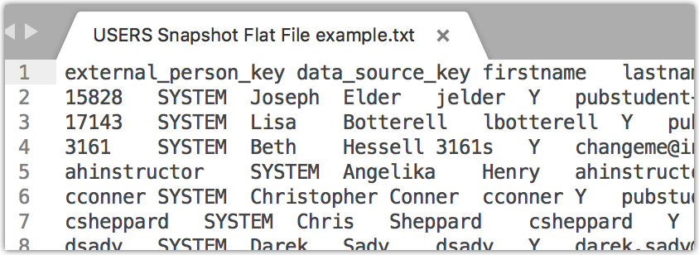
 | Capture Batch Restore Course List: On the Source EC2, run SQL to pull a list of real courses in Batch Restore Courses feed file format:  COURSES_Query_to_Batch_Restore.sql  Save the results of the query output as a comma-delimited text file (no headers). It should resemble this example:  COURSES_Batch_Restore_example.txt  Note: This Batch Restore course feed file will be used in step 17 to restore the courses onto the Destination EC2. | 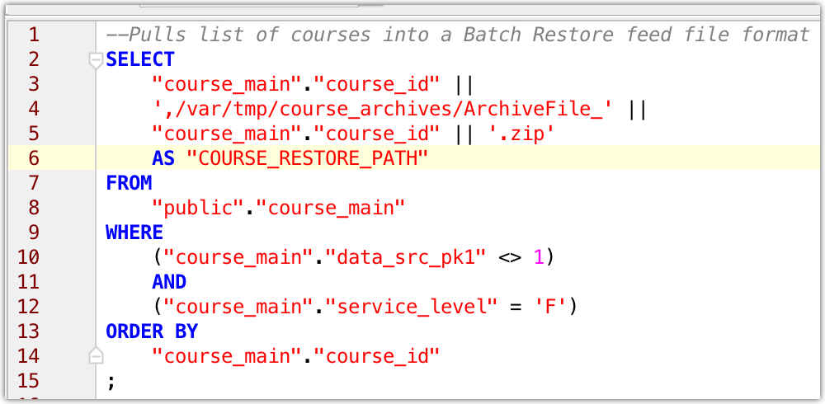  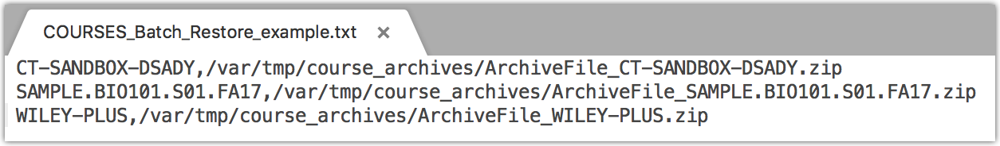
 | Capture Batch Archive Course List: On the Source EC2, run SQL to pull a list of real courses in Batch Archive Courses feed file format:  COURSES_Query_to_Batch_Archive.sql  Save the results of the query output as a comma-delimited text file (no headers). It should resemble this example:  COURSES_Batch_Archive_example.txt | 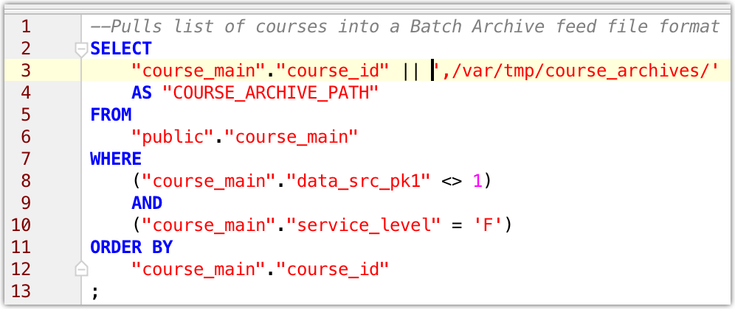  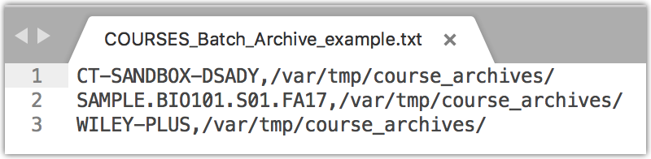

 | Batch Archive Courses: On the Source EC2, SFTP the COURSES_Batch_Archive file (from step 2 above) to an available directory (ex: /var/tmp).  Run the Batch Import-Export script against the file in archive mode:  sudo -u root /usr/local/blackboard/apps/content-exchange/bin/batch_ImportExport.sh -f /var/tmp/COURSES_Batch_Archive_example.txt -l 1 -t archive | 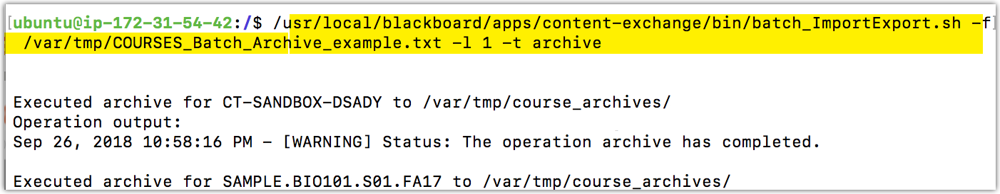
 | Retain Archived Courses: After the batch_ImportExport.sh script is finished, there will be an Archive File for each course in the directory specified. It’s usually easiest to SFTP the Course Archive zip files down to your local computer so they can be uploaded to the Destination EC2 in preparation for the Batch Course Restore process. | 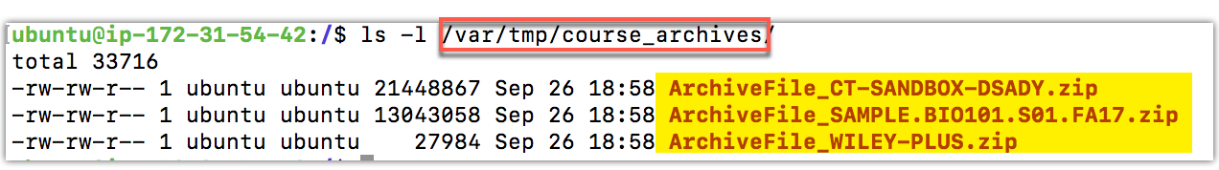  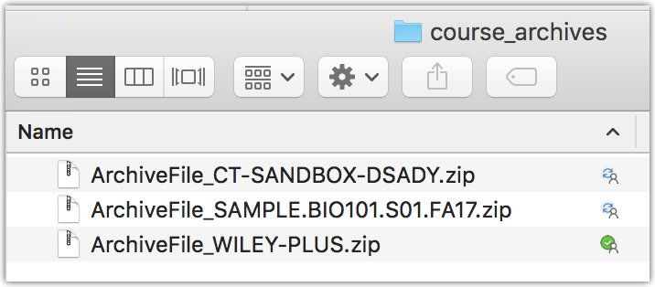
 | Capture Institutional Roles: On the Source EC2, run SQL to pull a list of non-default Institutional Roles in Batch Create Institution Roles File format:  ROLES_Query_to_Batch_Create_IRs.sql  Save the results of the query output as a tab-delimited text file (no headers). It should resemble this example:  ROLES_Batch_Create_Inst_Roles_example.txt  Administrator Panel Institution Roles | 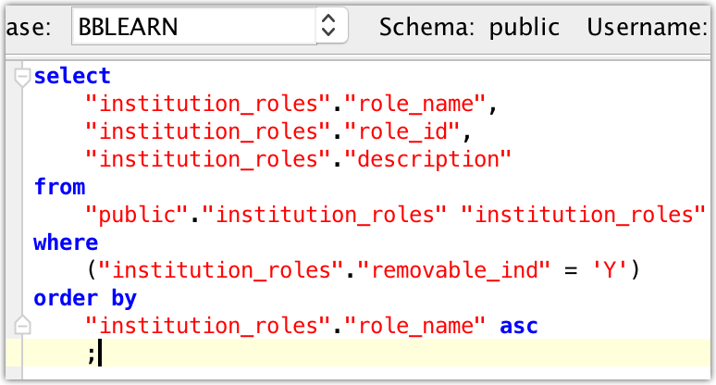  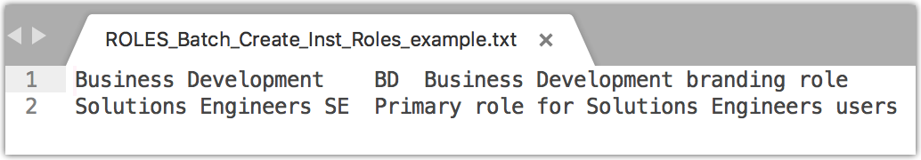
 | Capture Custom Course Roles: There is no batch import/export functionality for custom course roles. If any custom course roles need to be recreated on the destination EC2, login to the source EC2 as a System Administrator and make note of the Role ID, Role Name, and Privileges of any custom Course Roles.  Administrator Panel Course/Organization Roles | 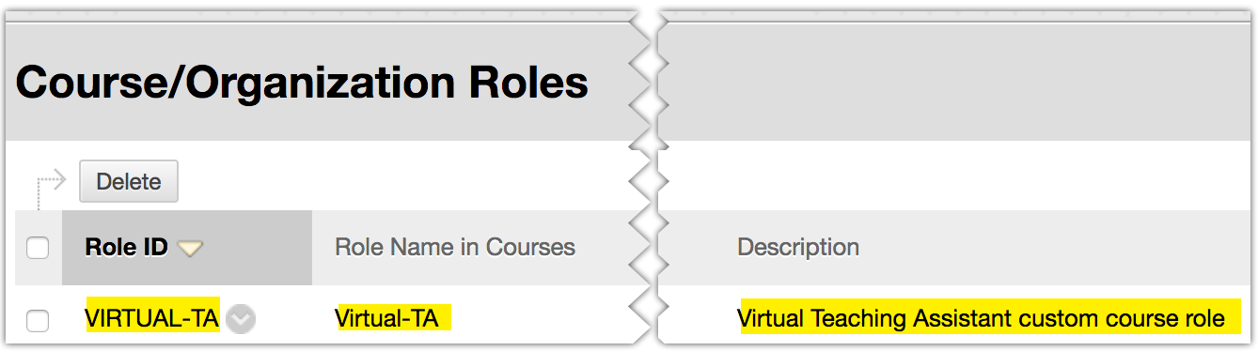  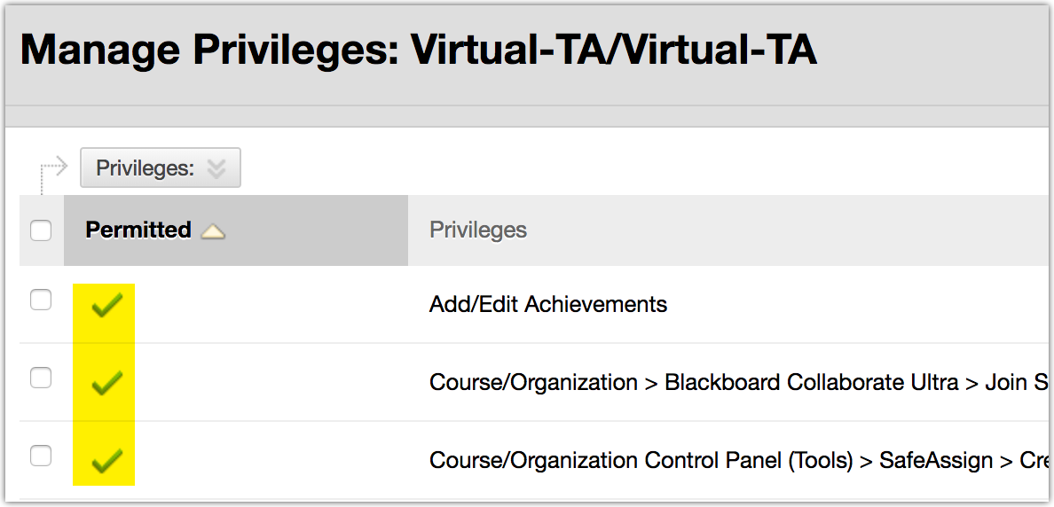
 | Capture Custom System Roles: There is no batch import/export functionality for custom system roles. If any custom System Roles need to be recreated on the destination EC2, login to the source EC2 as a System Administrator and make note of the Role ID, Role Name, and Privileges of any custom system roles.  Administrator Panel System Roles | 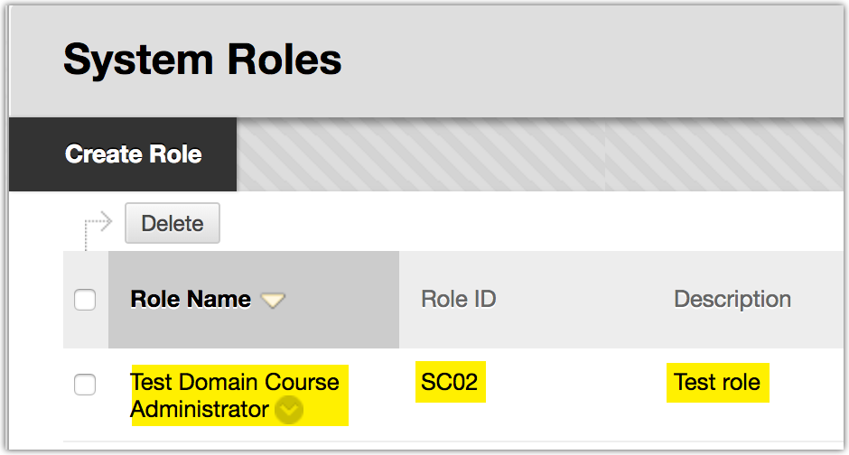  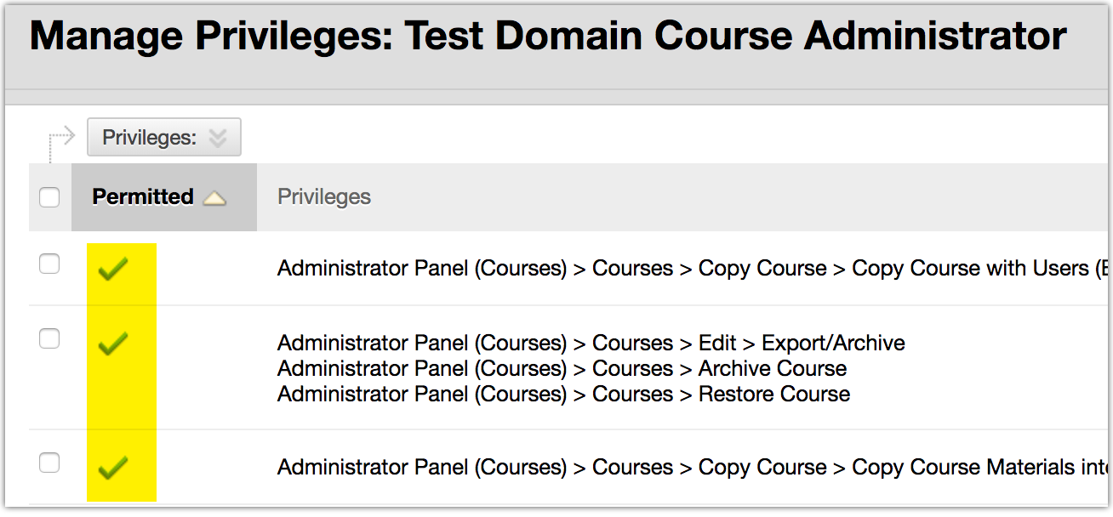
 | Capture Custom Data Sources: There is no batch import/export functionality for custom Data Sources (Data Source Keys -DSKs). If any custom Data Sources need to be recreated on the destination EC2, login to the source EC2 as a System Administrator and make note of the Key and Description of any custom Data Sources. If there are several custom Data Sources, the run the query below on the source EC2 to generate a convenient text list of custom DSKs for later recreation on the destination EC2:  DSKS_Query_to_List.sql  Administrator Panel Data Integration Data Sources | 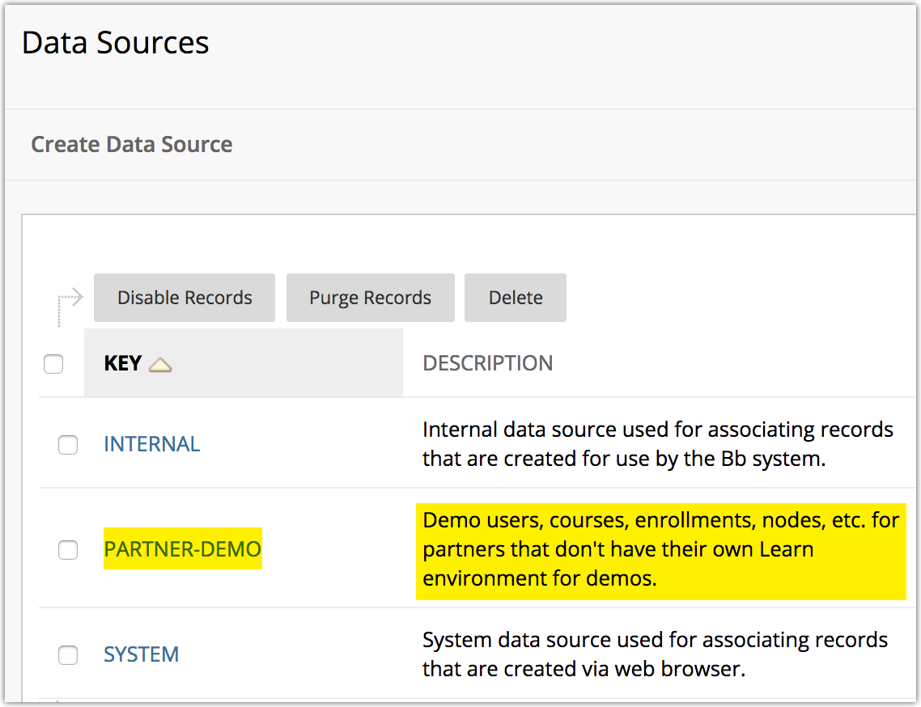  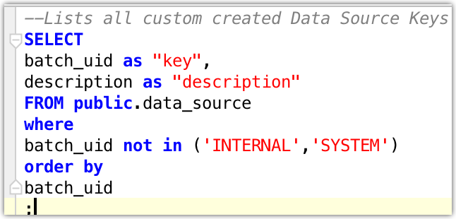
 | Export SIS Integrations: For any custom Student Information System Integrations that need to be recreated on the Destination EC2, login to the source EC2 as a System Administrator, navigate to the “Advanced Configuration” page for each SIS Integration, click Export Settings, and save the XML settings file. Repeat for each SIS integration.  Administrator Panel Data Integration Student Information System Integrations Advanced Configuration | 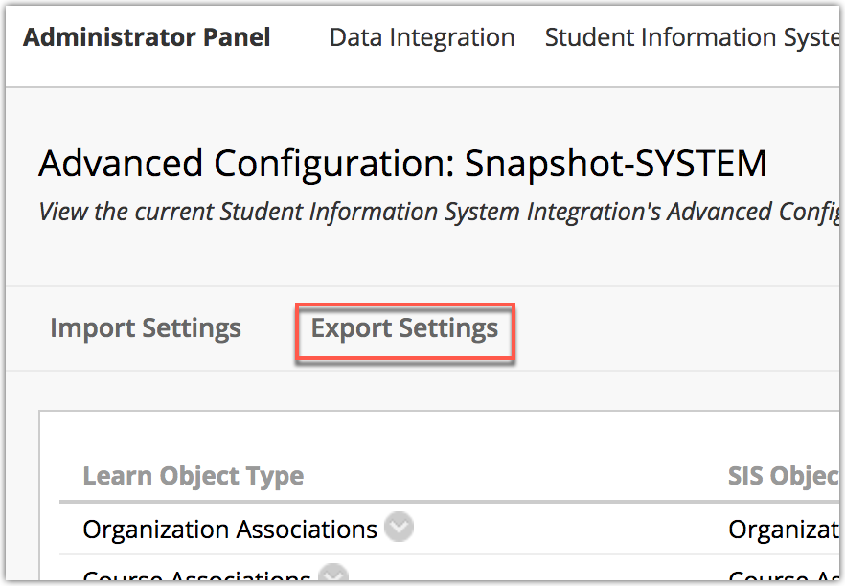

Loading T&L Data onto Destination EC2:
 | Re-create Custom System Roles: Login to the destination EC2 as a System Administrator and re-create the custom System Roles captured in step 7 above. Be sure to match the Role ID, Role Name, and Privileges of any custom System Roles.  Administrator Panel System Roles Create System Role | 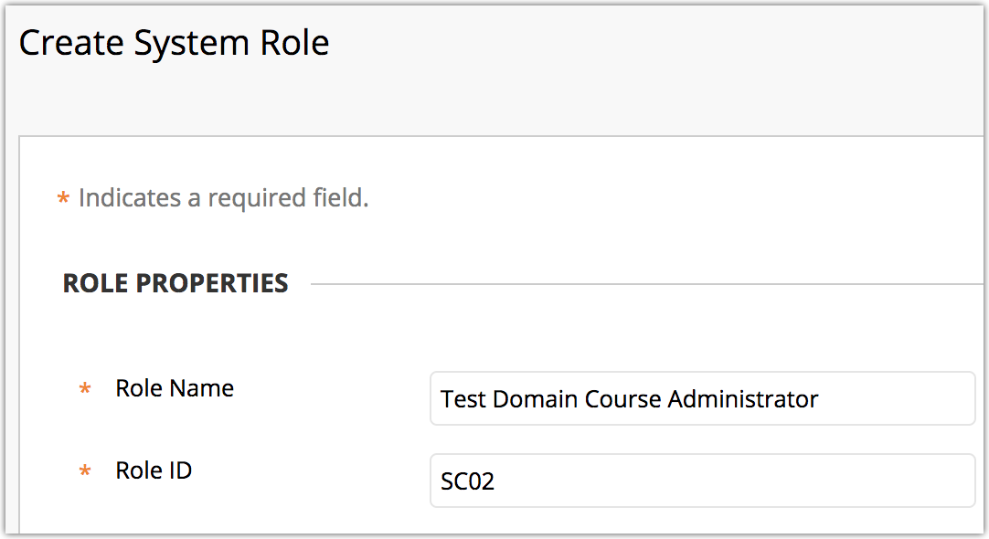
 | Re-create Custom Course Roles: Login to the destination EC2 as a System Administrator and re-create the custom System Roles captured in step 6 above. Be sure to match the Role ID, Role Name, and Privileges of any custom Course Roles.  Administrator Panel Course/Organization Roles Copy Course/Org Role:Instructor/Leader | 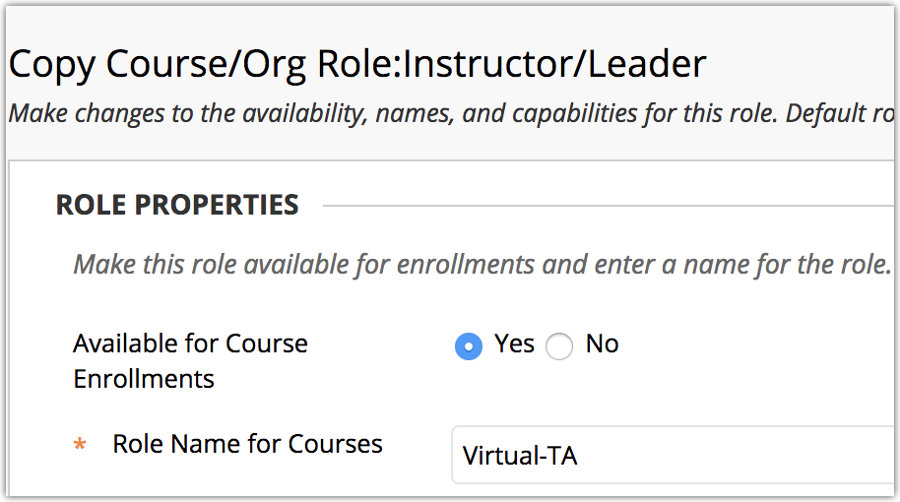
 | Re-create Institutional Roles: SFTP the Institution Roles batch file (created in step 5 above) to an available directory (ex: /var/tmp) on the Destination EC2. Run the Batch Import-Export script against the file:  /usr/local/blackboard/tools/admin/BatchCreateInstitutionRoles.sh /var/tmp/ROLES_Old_EC2_Batch_Create_Inst_Roles.txt  You can verify the newly created Institution Roles via:  Administrator Panel Institution Roles | 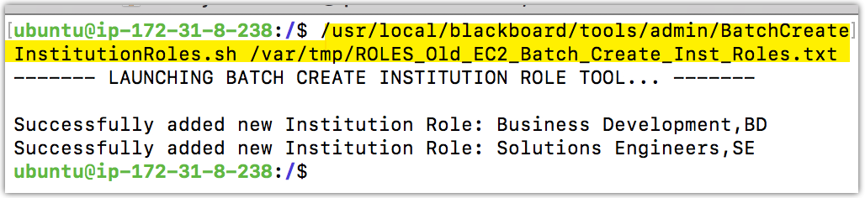  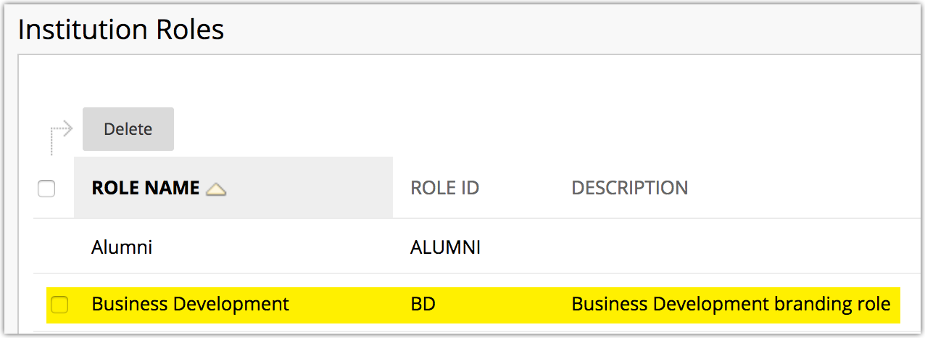
 | Re-create Custom Data Sources: Login to the destination EC2 as a System Administrator and re-create the custom Data Sources captured in step 8 above.  Administrator Panel Data Integration Data Sources Create Data Source | 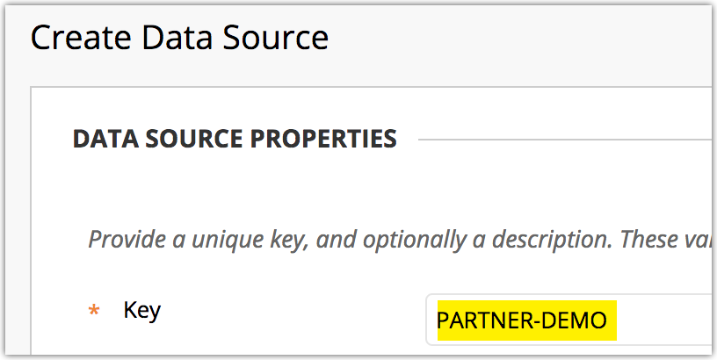
 | Import SIS Integrations: Login to the destination EC2 as a System Administrator, navigate to the “Student Information System Integrations” screen, and click Import Settings. Upload the XML settings file(s) you exported from step 9 above.  Administrator Panel Data Integration Student Information System Integrations Import Settings | 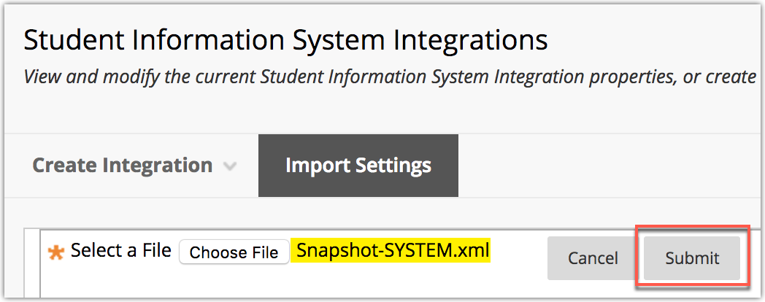  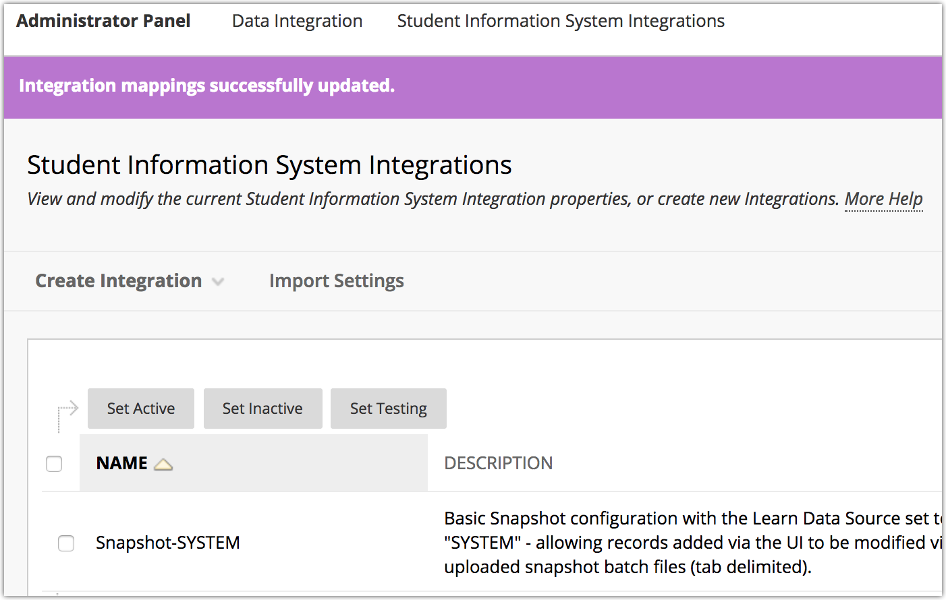
 | Upload Archived Courses: SFTP the Course Archive zip files (from step 3 above) to the Destination EC2.  Note: If you use the same directory structure referenced in your Courses Batch Archive file (ex: /var/tmp/course_archives), you can reuse the same file for the Courses Batch Restore. | 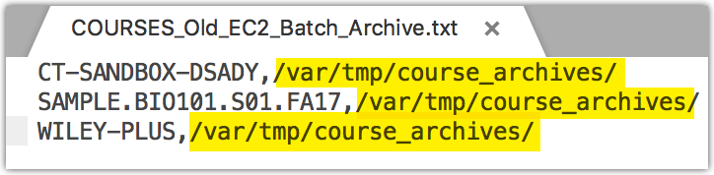  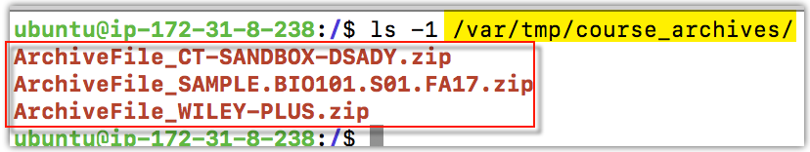
 | Batch Restore Courses: On the Destination EC2, SFTP the COURSES_Batch_Restore file (from step 2 above) to an available directory (ex: /var/tmp).  Run the Batch Import-Export script against the file in restore mode:  sudo -u root /usr/local/blackboard/apps/content-exchange/bin/batch_ImportExport.sh -f /var/tmp/COURSES_Batch_Restore_example.txt -l 1 -t restore | 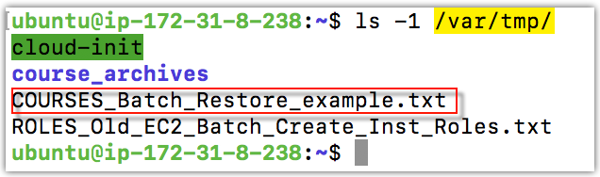  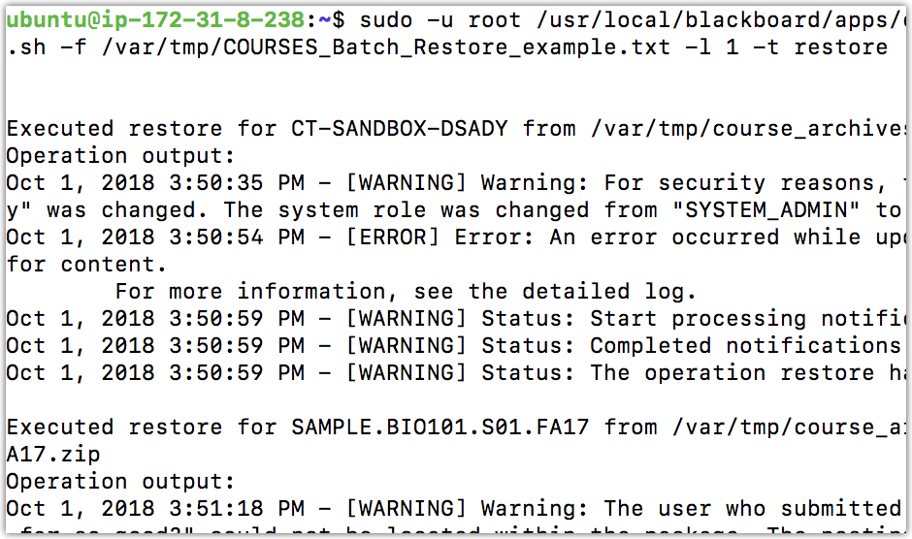
 | Update Users (optional): To re-associate original System, Course, and/or Institutional Role assignments, navigate to Administrator Panel Data Integration Student Information System Integrations <your integration> Upload Feed File. Select and run the User Snapshot feed file (created in step 1 above) via a Student Information System Data Integration. | 